================================================
EXCEL PHASE NOTES
DataCo Supply Chain Project
Date: May 2026
================================================

BUSINESS PROBLEM
------------------------------------------------
The company is having delivery delays and uneven
profit across regions, shipping modes and products.
This project finds where operations are failing
and where profit is being lost.

IMPORTANT COLUMNS I IDENTIFIED
------------------------------------------------
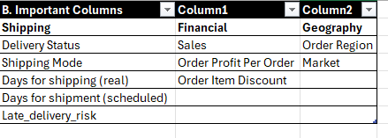
MISSING VALUES CHECK
------------------------------------------------
I checked these important columns using COUNTBLANK:
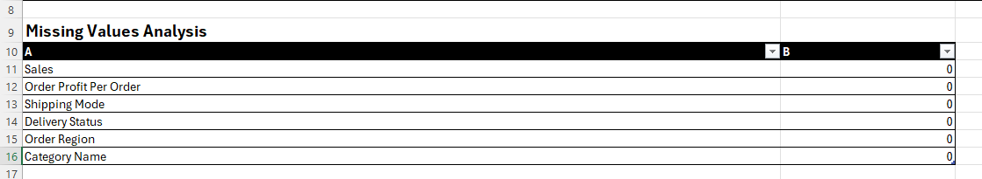
Good news - dataset is clean, no missing values found

CLEANING I DID
------------------------------------------------
Removed these columns because they were useless
for analysis:
- Customer Email
- Customer Password
- Product Image
- Product Description

These columns had no business value and were
just adding clutter to the dataset

NEW COLUMNS I CREATED
Screenshot saved: Calculated_Columns.png
Shows Profit Margin % with red highlights for losses,
Delivery Delay with positive/negative values,
and Discount Bucket categories Low Medium High
------------------------------------------------
1. Profit Margin %
Formula = Order Profit Per Order divided by Sales
What it tells me:
- Positive number = company making money on that order
- Negative number = company losing money on that order
- I highlighted negative values in red so easy to spot

2. Delivery Delay
Formula = Actual shipping days minus scheduled days
What it tells me:
- Positive number = order was late by that many days
- 1 means 1 day late, 2 means 2 days late
- Negative number = order delivered early
- 0 means delivered exactly on time

3. Discount Bucket
Grouped discounts into Low, Medium, High
using nested IF formula
Makes it easier to compare discount impact on profit

WHAT I LEARNED TECHNICALLY
------------------------------------------------
- COUNTBLANK = how to check for missing data
- IF formula = how to create categories from numbers
- Calculated columns = how to create new business metrics
- Conditional formatting = how to highlight problems visually
- Pivot tables = how to summarize 180k rows into patterns
- Sorting H to L = how to find biggest problems first

PIVOT TABLE FINDINGS
------------------------------------------------
PT1 - Shipping Mode Delay:
I put Shipping Mode in rows and average delivery
delay in values
- Second Class had highest average delay about 2 days
- Standard Class performed surprisingly well
despite handling most orders
- BUT later SQL showed First Class is actually worst
by late delivery percentage = 95.32%
- Excel measured average delay days
SQL measured late delivery percentage
- These are two different measurements
- Percentage is more accurate than average days
- Business meaning: First Class has biggest problem
despite being most expensive shipping mode

PT2 - Region Profitability:
I put Order Region in rows with total profit
and average delay in values
- Western Europe and Central America = highest profits
- Central Asia = high delays AND low profit = danger zone
- SQL later confirmed Central Asia and Central Africa
are both double trouble zones
- Business meaning: Central Asia needs urgent review
because it has both problems at same time

PT3 - Category Performance:
I put Category Name in rows with sales, profit
and profit margin in values
- Fishing = highest total sales
- Golf Bags and Carts = highest profit margin about 17%
- Strength Training = weak profitability despite good sales
- Business meaning: company should focus more on Golf
and investigate why Strength Training margins are weak

PT4 - Discount Impact:
I created Discount Bucket column first
then put it in rows with average profit margin in values
- High discount orders = only 9% average profit margin
- Company barely making money on heavily discounted orders
- SQL later confirmed HIGH discount avg profit = 18.41
vs LOW discount avg profit = 23.75 per order
- Business meaning: giving too much discount
is seriously hurting company profitability

PT5 - Shipping Mode vs Profit:
I put Shipping Mode in rows with profit and delay
- Standard Class = highest sales volume
AND near on time delivery
- Second Class = operationally inefficient
- Business meaning: Standard Class is most reliable
shipping mode despite handling most orders

MY OWN SURPRISE FINDING
------------------------------------------------
While looking at the discount pivot table I noticed
that medium discount orders have NEGATIVE profit margin
AND most of those orders use Standard shipping mode

This means:
Medium discount + Standard shipping = double loss
Company is losing money on these specific orders

This was completely my own observation
Nobody told me to look for this
I found it myself while exploring the data

Business recommendation:
Company should immediately review medium discount
strategy specifically for Standard shipping orders

SQL CORRECTIONS TO EXCEL FINDINGS
------------------------------------------------
After doing SQL analysis I found that some Excel
findings needed to be updated with more accurate numbers

Excel said Second Class was worst shipping mode
SQL showed First Class is actually worst
by late delivery percentage = 95.32%
Lesson: percentage is more accurate than average days

Excel showed Central Asia had high delay and low profit
SQL confirmed this AND also found Central Africa
is another double trouble zone
Both are remote locations with high shipping costs

Excel showed high discount reduces profit margin
SQL confirmed this with exact numbers
HIGH discount avg profit = 18.41 per order
LOW discount avg profit = 23.75 per order
SQL gave us the exact difference = 5.34 per order

KEY LESSONS FROM EXCEL PHASE
------------------------------------------------
1. Always verify Excel findings with another tool
because Excel shows averages which can mislead
2. Percentage is more accurate than raw count
3. One pivot table never tells complete story
need to connect findings across multiple pivots
4. Data does not always match our assumptions
I thought USA would be most profitable
but Western Europe was actually highest
5. Always ask WHY after finding WHAT
not just what happened but why it happened

